Timberdoodle/American Woodcock (Scolopax minor)
Rehabilitation Protocol
Valerie Slocum, Rehab Coordinator Wildwoods, MN
Tim Jasinski, Rehab Coordinator, Lake Erie Nature and Wildlife Center, OH
Gail Buhl, P4W, The Raptor Center at the U of M, MN
July 2022

American Woodcocks are very secretive in the wild and are not often presented to wildlife rehabilitators. When they are presented, it is often a few of the chicks or an injured adult. The following information is from the Lake Erie Wildlife Rehabilitation Center and compiled by Tim Jasinski, Valerie Slocum and Gail Buhl. Each year Lake Erie admits 200+ adult American Woodcock that are injured when they are passing through Cleveland, OH during migration every year.

Conservation Status: Population declining: https://www.allaboutbirds.org/guide/American_Woodcock/lifehistory
https://www.iucn.org/commissions/ssc-groups/birds/woodcock-and-snipe

General Natural History
- Range/Migratory Status
  - Found in the Eastern half of the United States.
  - Migrate in October to the Southern United States.
- Natural Diet
  - Primarily feed on earthworms (75-80%), also spiders, flies, elaterial beetles (click beetles).
  - Long Bill specialized for feeding on earthworms, stout head with large eyes set far back for rearview binocular vision.
- Defenses
  - Camouflage: their mottled leaf-brown patterns blend in with the forest floor.
  - Freezing
  - Flushing: The woodcock will attempt escape by flying upwards.
- Predators
  - Fox
  - Coyote
  - Northern Goshawk
  - Owls
  - Humans: Hunting season runs from approximately 9/25-11/8 in Minnesota

Infant Care
- Development of Young
  - Aging Chicks
    - There is not a good way to age. They get the same care regardless.
  - Weights
    - Body Weight at hatching is 11-13g
  - different stages of growth
    - Parents feed for approximately 1 week
    - Short flights by 14 days, longer flights by 18 days, able to fly in 25 days
    - Grow very quickly and will be nearly full size at 30 days
- Housing Setup
  - Infant
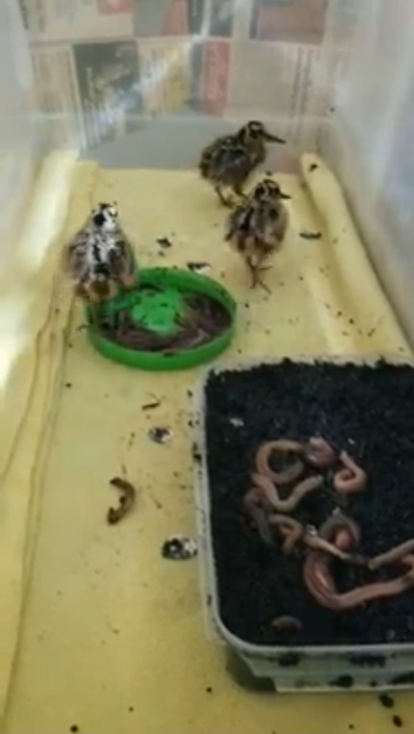
    - Housing similar to waterfowl set up using a mirror, feather duster, and a heating lamp, but excluding pool. Place feather duster at the warm end of the cage. Ideal heat lamp: Fluker’s 100w ceramic heat bulb to keep between 90-100°F.
    - If the container is clear, tape newspaper to the outside of the container for stress reduction as it reduces visual stimulus.
    - Top should be wire with towels covering it to keep it dark.
    - Substrate/Floor of caging can be towel or fleece. Towels need to be string/fray free with a tight weave on the towel to prevent toenails from snagging.
    - Can keep young in incubator but may not be ideal depending on incubator needs for songbirds and the amount of activity where the incubator is located. Unknown temperature for incubator.
  - Juvenile- House like adults-see below
  - Pre-Release-House like adults—see below
- Feeding
  - Types of Food
    - Earthworms that have been cut up.
    - Red Wigglers
    - Bloodworms (live or frozen)
  - Feeding Frequency and Amount
    - When they start calling, it is time to feed them. They may need to be fed approximately every 15-20 minutes until they begin to self-feed.
    - They have a high metabolism. Put LOTS of worms in cage with them. Check to see if they are eating on their own and replace food when needed.
    - Make sure food is always available.
  - Feeding methods/How to Present food
    - Using forceps or hemostats with a worm, slowly put your hand in housing and put piece of earthworm or red wiggler to the corner/base of their bill with a little bit of moisture.
    - The young usually pick up feeding quickly, but if they don’t, do not force feed. If the bird is not taking food, be patient. Give them a break and try again later and continue this until they do pick it up.
    - If the young are using the feather duster as shelter or a hide and they stick their beak out, you can try to feed them while they are in there without them seeing you.
    - Place lid (size of peanut butter jar lid) with red wigglers and another larger container with soil and nightcrawlers.
  - Vitamins
    - Supplement vitamins on worms SID
      - Lafeber vitamins
      - Sprinkle oyster shell grit on their food where they probe (container with earthworms).
- Handling/Restraint- Handle only once/day. Can use a small butterfly net inserted into the cage to cover the bird and then can handle with hands in a bird banding hold. Move quickly, quietly and efficiently to examine and move them to a paper bag/dark container so their housing can be cleaned and bird put back.
- Weighing
  - Weigh once a day. Should be at the same time as cleaning to limit handling and reduce stress.
- Cleaning
  - Clean once a day. Should beat the same time as weighing to limit handling and reduce stress.
- Common Medical Issues: In House
  - Angel wing (vitamins E, D3, and manganese )
  - Metabolic Bone Disease – diet related
  - Foot issues: housing related
    - Open wounds, lameness, pink areas
  - Hypothermia
Note the thick foam on the ceiling
- Release
  - Release Criteria (physical, mental, etc.)
  - Release Site Considerations
Adult Care
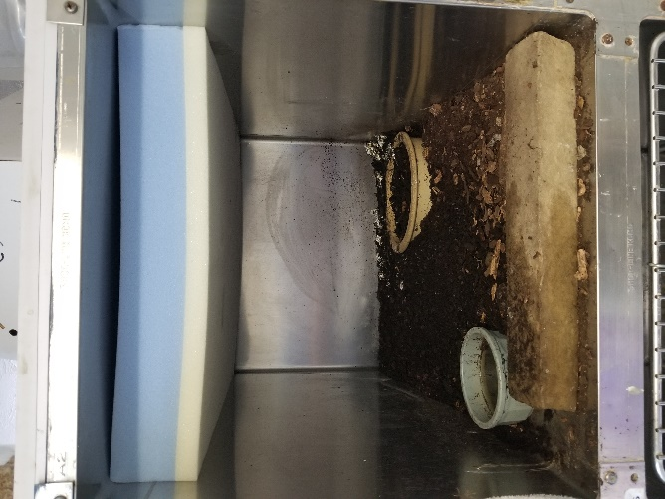
- Housing Setup
  - Steel cages or kennels will work.
  - Put a dark towel on the inside of the door of the cage so the bird can’t get stuck in the bars using a binder clip to keep it taught.
  - It should be dark inside cage.
  - Substrate should be semi moist dirt.
  - Place a brick in the front to keep dirt from falling out.
  - Give them a small bowl of water they can walk through.
  - Use a large dog bowl (3-4” deep) so the birds can probe for worms. The top of the bowl should be level with the substrate dirt. Dig a hole and put the food dish in there.
  - Place a piece of foam on the ceiling of the cage to protect birds from injuring themselves when they attempt to fly/flush.
  - You may place a wooden hide box inside of the cage.
  - House Woodcock separately whenever possible.
- Feeding
  - Keep live food away from heat source.
  - Types of food
    - Earthworms/nightcrawlers
    - Red Wigglers
  - Feeding Frequency and Amount
    - Put 40-60 live nightcrawlers.
  - Feeding methods/How to present food
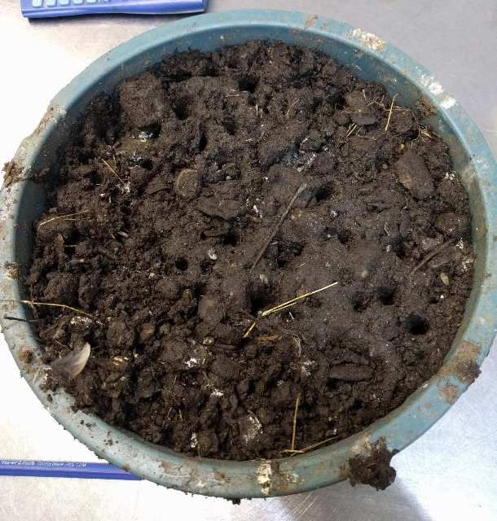
    - Put nightcrawlers in a dish and put dirt on top. The soil in the dish should be slightly moister than the rest of the substrate in the cage. The soil should be deep enough for them to probe.
- Water Presentation
  - Give them a small bowl of water they can walk through.
- Handling/Restraint
  - When you need to capture, Woodcock will typically freeze when you crack the door open. Slowly slide a butterfly net and put over the bird to capture.
  - Hold in Bander’s grip. They have very strong feet and will kick and can jump out of hand if not held in bander’s grip.
- Weighing
  - Weigh once a day. Should be at the same time as cleaning to limit handling and stress.
  - Weigh in paper lunch bags (double bagged). Binder clip the bags shut and leave them in there while cleaning.
  - Males weigh an average of 150g-170g, females weigh an average of 170g-200g.
- Cleaning
  - Once a day. Should be at the same time as weighing to limit handling and stress.
- Common Medical Issues: Admission
  - Eye injuries: They often have eye ruptures. If so, euthanize.
  - Wing/Leg/Coracoid fractures from hitting windows
    - Wing to body wrap works with paper tape well for coracoid fractures
  - Leg fractures that are high up should be euthanized. They need to walk to feed, and they are very high stress.
  - Unless veterinarian is on-site, Woodcock are not taken to the vet due to the high stress it would cause. Stress very easily kills this species
- Common Medical Issues: In House
  - On average, they lose weight 4 -5 days in a row and then start gaining weight rapidly.
  - Foot issues – housing related
  - Traumatic injuries
  - Hypothermia
- Initial Care and Stabilization
  - When they first arrive, place in a “black box” to let it rest for 20-30 minutes. Then examine quickly, medicate if needed, and then place in caging. Do not extend your time in handling them.
    - Medicate on recommendations from veterinarian. Meloxicam, Eye Moist, Cipro are all commonly used.
  - Weigh them with a scale that measures to the tenth of a gram.
  - If it is not eating, sometimes the meds could be the issue. BID (Twice per day) meds 3-4 days, then stop the meds in case the GI is upset.
  - DO NOT TUBE FEED
- Euthanasia Considerations
  - Leg fractures that are high up should be euthanized. They need to walk to feed, and they are very high stress. The amount of care needed causes too much stress. Stress kills these birds easily.
  - It will be up to the rehabilitator’s discretion to determine if the bird is too stressed to continue rehabilitation.
- Release
  - Release Criteria
    - Unable to fully test fly a woodcock. Observe to see how the wing sits and how they jump/flush. Can have 4 people holding corners of a sheet so when the bird flushes up, it hits the sheet. Wings should make a whistling sound.
  - Release Site Considerations
    - Habitat: Prefers young forest and abandoned farmland mixed with forest. Forest openings and old field provide display areas (singing grounds) for males and grasses, herbaceous cover, and low shrubs are replaced by young trees. Alder, young Aspen, and Birch provide appropriate mixture.

Resources:
https://timberdoodle.org/sites/default/files/northern_forest_woodcock_bmp_nrcs_wildlife_insight.pdf
https://sites.tufts.edu/babybirds/common-name/sandpipers-and-allies/
https://birdsoftheworld.org/bow/species/amewoo/cur/introduction
Range Map: https://www.allaboutbirds.org/guide/American_Woodcock/maps-range
https://www.dnr.state.mn.us/forestlegacy/koochiching_washington/americanwoodcock.html
https://www.dnr.state.mn.us/birds/woodcock.html
https://animaldiversity.org/accounts/Scolopax_minor/
https://www.iucn.org/sites/dev/files/content/documents/2020_woodcock_and_snipe_sg_report_publication.pdf
https://www.iucn.org/commissions/ssc-groups/birds/woodcock-and-snipe
Bander’s grip: https://www.alamy.com/stock-photo-a-bird-bander-holds-a-black-throated-blue-warbler-dendroica-caerulescens-21238335.html
Heat Bulb: https://www.amazon.com/Flukers-Ceramic-Heat-Emitter-Reptiles/dp/B0002DHO6S

